Amazon QuickSight



**Introduction to Amazon QuickSight**

Amazon QuickSight is a cloud-scale business intelligence (BI) service that is used to deliver easy-to-understand insights to the people. It is used to build visualizations, perform ad hoc (temporary) analysis, and quickly get business insights from the data. Amazon QuickSight seamlessly discovers AWS data sources, enables organizations to scale to hundreds-of-thousands of users, and delivers fast and responsive query performance by using the Amazon QuickSight super-fast, parallel, in-memory, calculation engine (SPICE).

# Key features

1. Enable BI for everyone.
2. Perform advanced analytics with ML insights.
3. Embed analytics to differentiate applications.

# Benefits of Amazon QuickSight

1. Connect and scale all of your data.
2. Build customizable dashboards.
3. Leverage ML integrations for insights.
4. Enable true self-service BI for everyone.
5. Native AWS services integrations.
6. No servers to manage
7. Pay by usage.
8. Built-in security, compliance, and governance.

**Procedure to configure Amazon QuickSight**

# Step – 1

Login to your AWS Management Console through the ‘Root user’.

# Step – 2

Create a new IAM user, and give the policy access to Amazon QuickSight.

# Step – 3

Now, re-login to your AWS Management Console through the ‘IAM user’. This method is always recommended for best security purposes.

Set up the ‘Region’ accordingly to your nearest region.

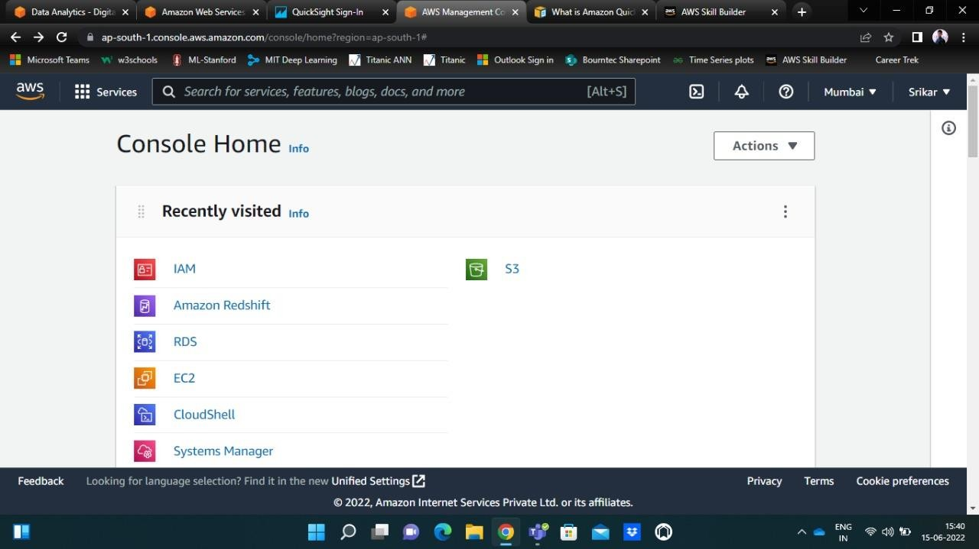

# Step – 4

Click on the ‘Services’ section on the top left hand corner on the navigation pane. Then click on ‘Analytics’ and click on the ‘QuickSight’ option that’s shown.

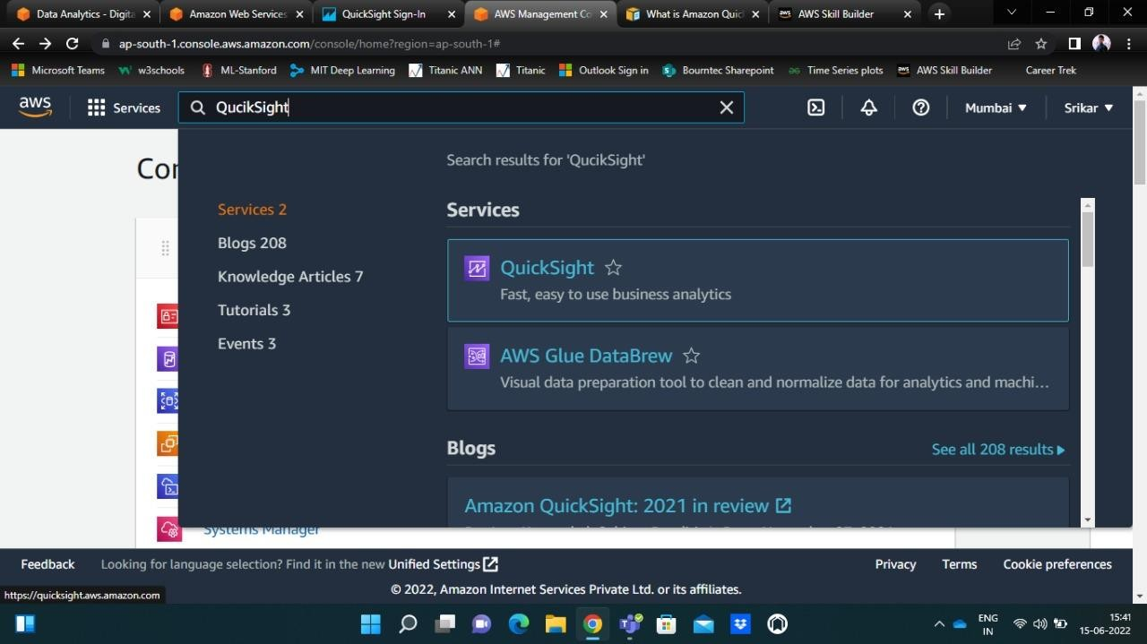

# Step – 5

You will then be automatically re-directed to a new window of QuickSight. Now, you need to ‘Sign-up’ your QuickSight account.

There are two ways to set-up QuickSight account. One is the ‘Standard’ method, and the other one is the ‘Enterprise’ method. You can choose accordingly as per your requirement.

A few details will be asked like QuickSight username, an email for sending alerts. Enter those details.

Upon successful completion of the sign-in process, you will be re-directed to the QiuckSight home page.

On the top right-hand side of the QuickSight page, you can see your ‘Account ID’.

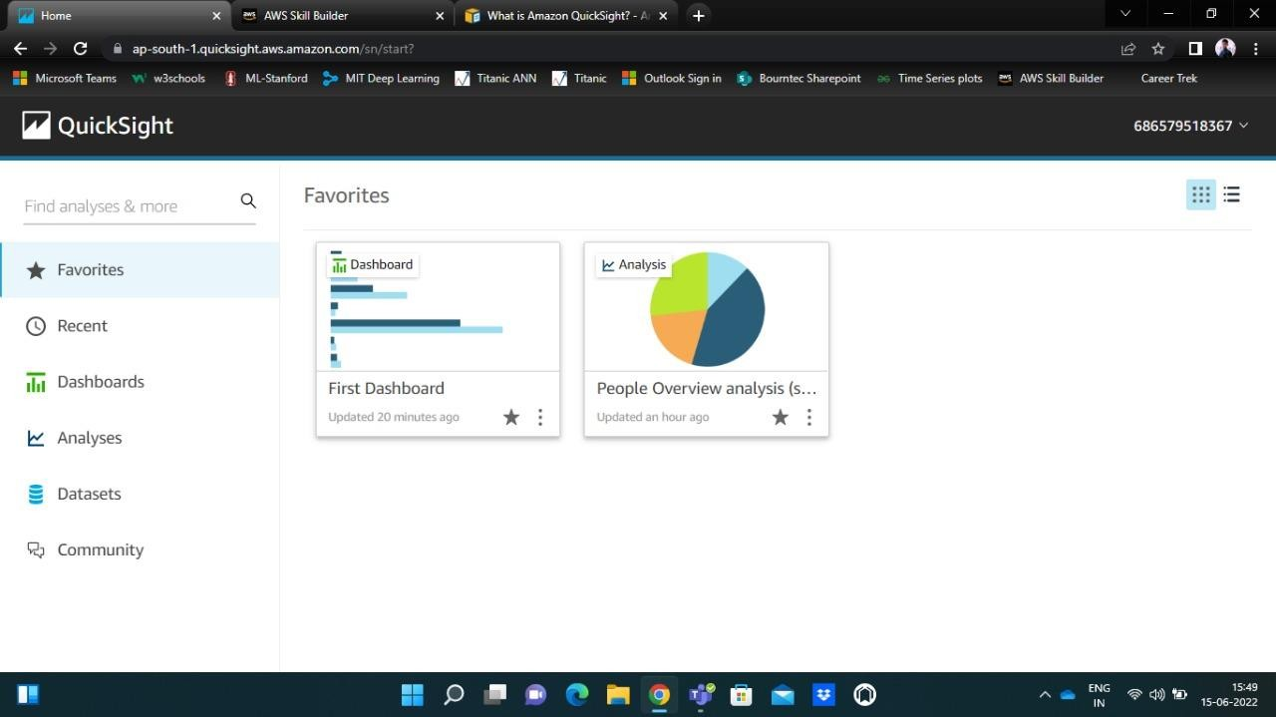

# Step – 6

You can find a wizard on the left side showing a few options like Dashboards, Recent, Favourite, Analyses, Datasets, etc.

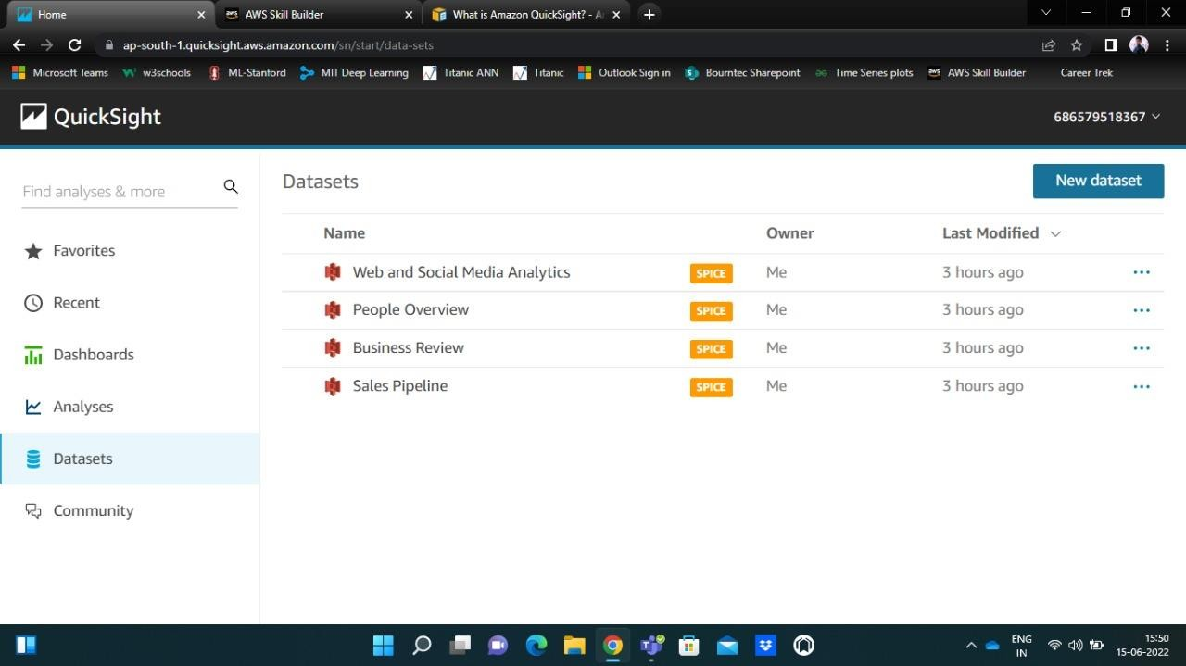

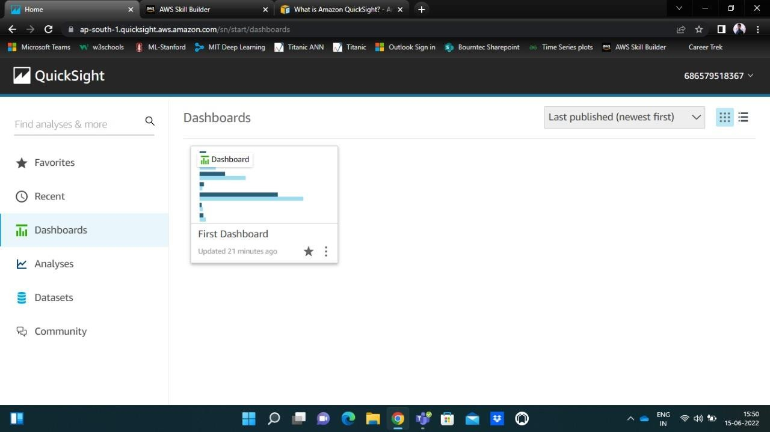

This is the standard way to configure and set-up Amazon QuickSight.

# Creating a sample Dashboard (using QucikSight Standard)

There are four sample datasets present in QuickSight.

Select any one dataset for your analysis. Upon selecting a particular dataset, the QuickSight analysis interface opens up as shown below.

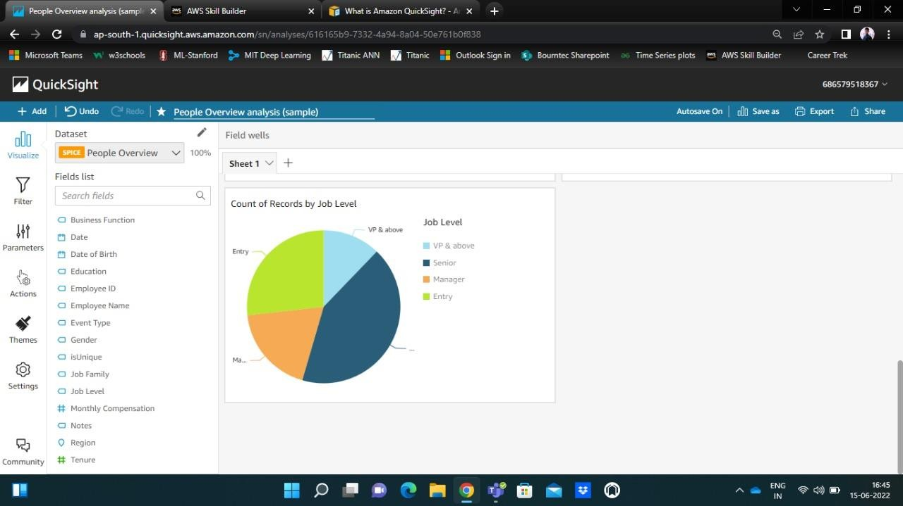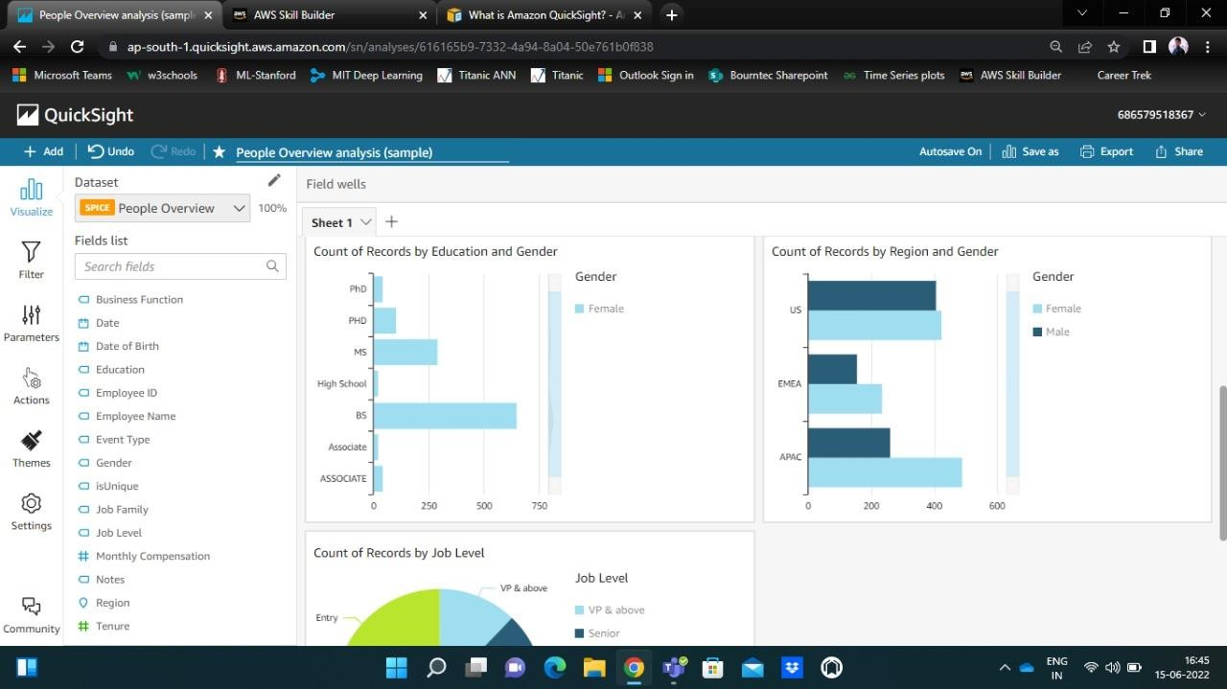

You can drag and directly drop the features into the analysis area, and visualize the corresponding results.

You can add some filters under ‘Filter’ option to customize your parameters to get more customizable insights.

On the top right-hand corner of the navigation pane you can find ‘Save as’ option. You can save your work by just giving a name.

Under the ‘Export’ option, you and either have a print of your work or you can download the file as a PDF on your local machine.

Using the ‘Share’ option, you can either publish your dashboard or, can share your analysis with authors and admins in your QuickSight account.

# Working with the AWS QuickSight Enterprise version

The ‘Enterprise’ version comes with a one-month free access. You will be charged accordingly upon exceeding the free-tier limit.

In this section, we shall try to understand the ‘Enterprise’ version of QuickSight, and some often used options like

1. Filter
2. Parameters
3. Insights
4. Adding calculated fields
5. Sharing, Publishing and Exporting dashboards
6. Anomaly Detection
7. Featured ML insights

The above mentioned are some of the additional options that are available in the ‘Enterprise’ version.

The below image gives a brief idea of the differences between the Standard version and the Enterprise version.

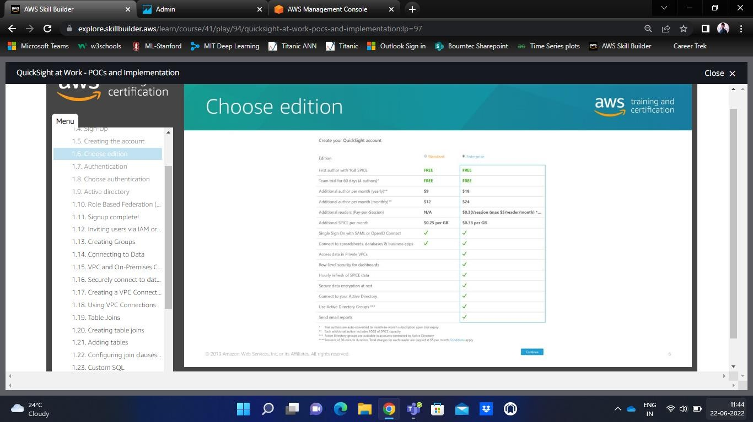

**Step – 1** Set-up procedure

Login into your AWS Management Console and type QuickSight in the search bar. Upon clicking, you will be taken to a new window of QuickSight home page.

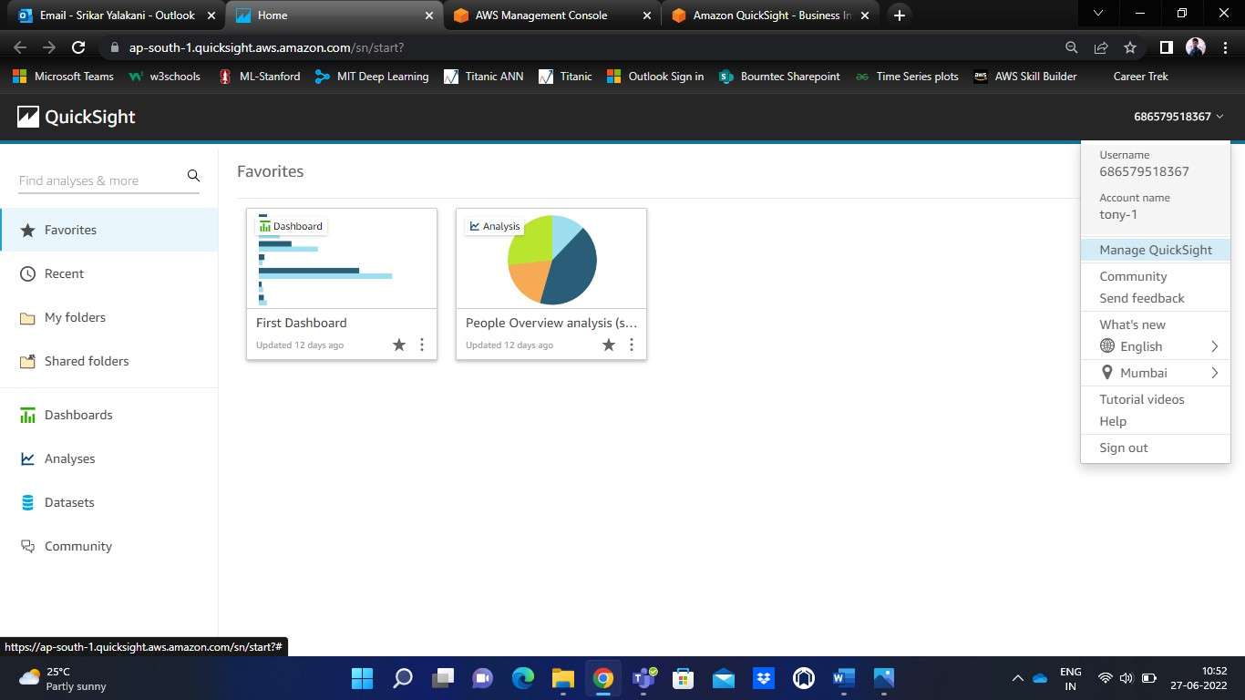

**Step – 2** Configuring QuickSight

You will find your QuickSight account number on the top right-hand corner. Click on ‘Manage QuickSight’ to update your current AWS QuickSight version to AWS QuickSight Enterprise version. Then, confirm the same by clicking OK.

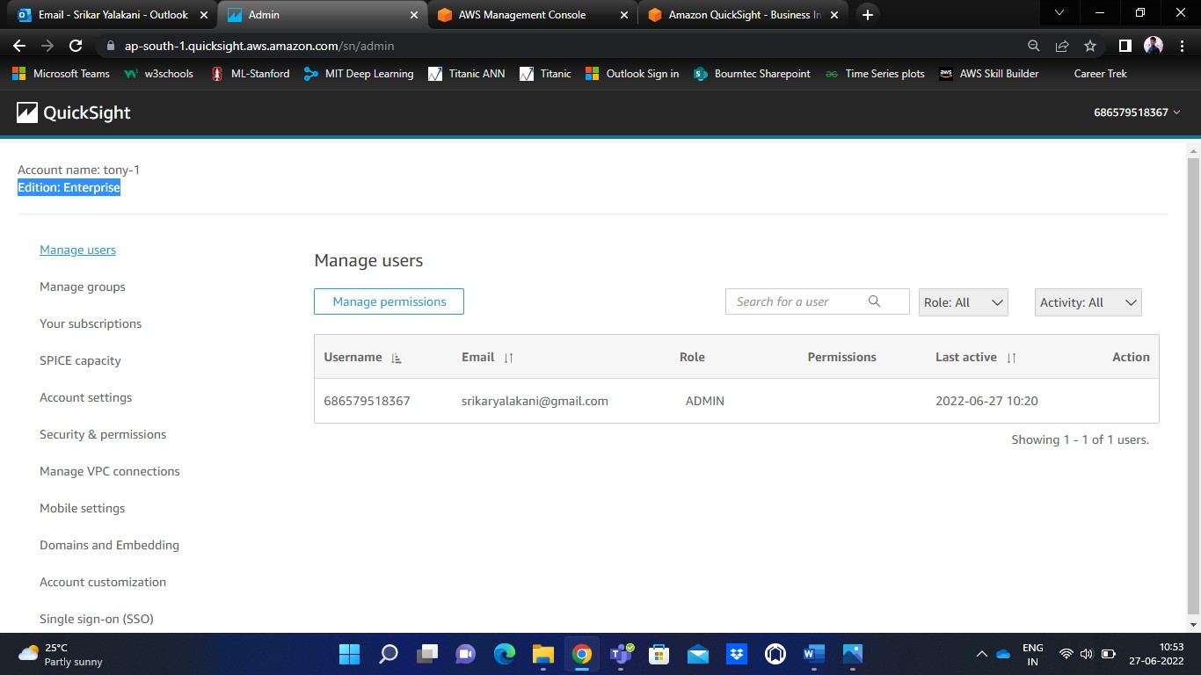

You can notice your Account name and Edition displayed on the top left-hand corner of the screen.

Under the ‘Manage VPC connections’ select the default connection to set-up the VPC connection.

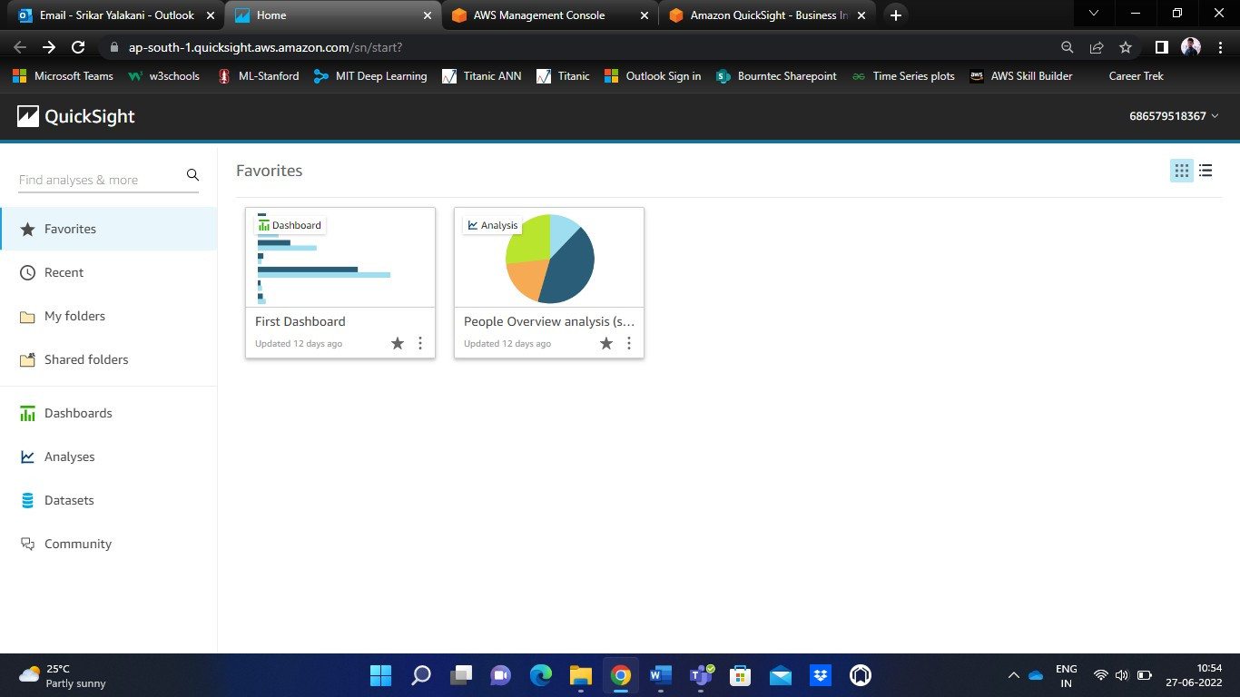

You can notice few new options – My folders, Shared folders.

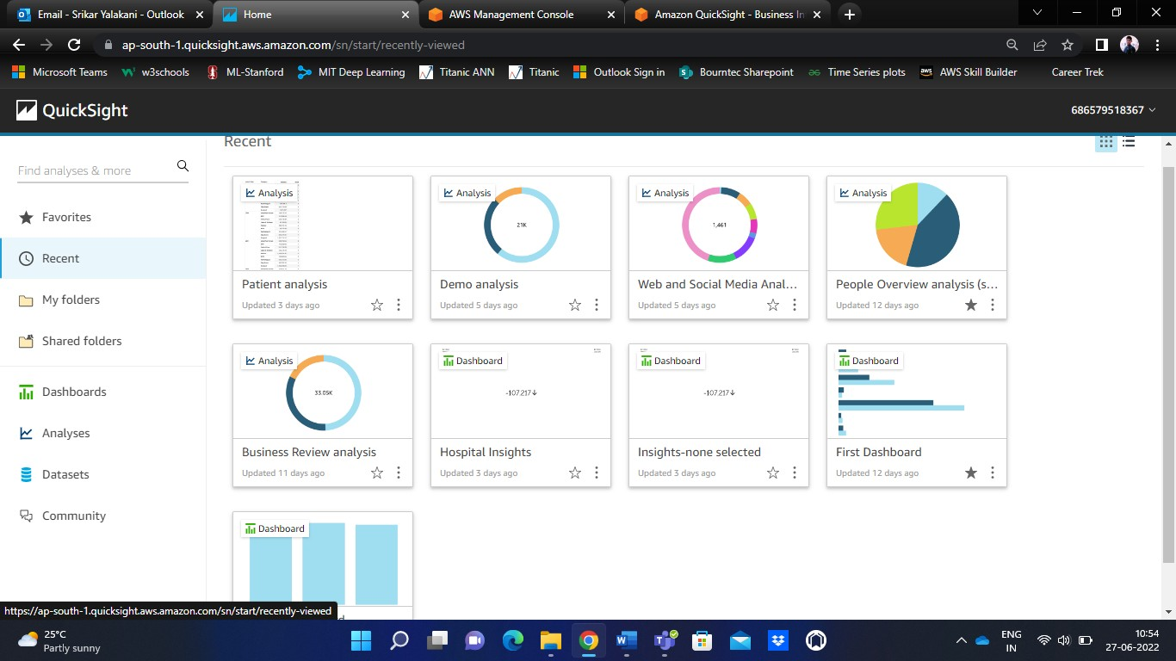

Under ‘Recent’, you can find your recently used dashboards.

**Step – 3** Processing a Dataset

To add a new dataset, click on ‘New Dataset’.

Then click on ‘Upload a file’ to upload it from the local computer, or you can connect to some other datasets of S3, RDS, Athena, Redshift, PostgreSQL, etc.

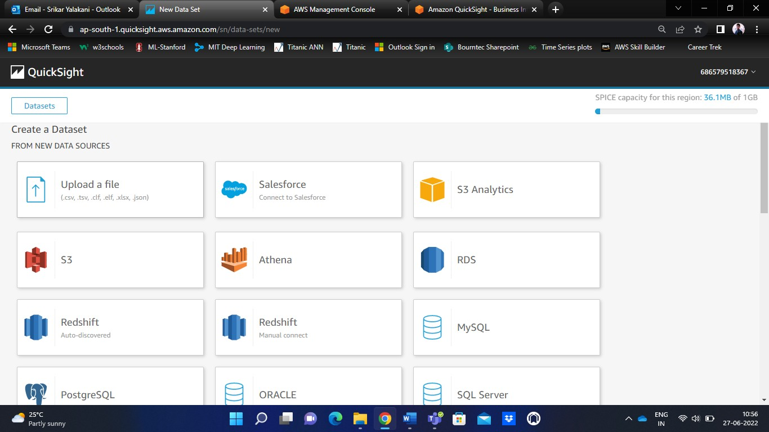

After uploading, you can find your dataset under ‘Datasets’ section.

For example, I have downloaded ‘Patients-Info.csv’ from Kaggle and uploaded the same.

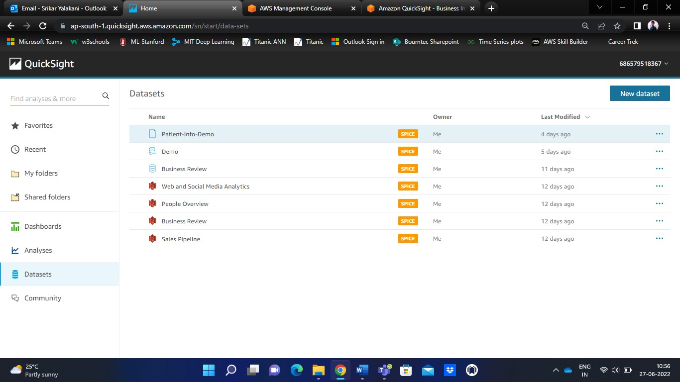

You can share, edit, duplicate, or can create analysis on the dataset. Notice the below image for these options. You will also be displayed the number of rows in the dataset.

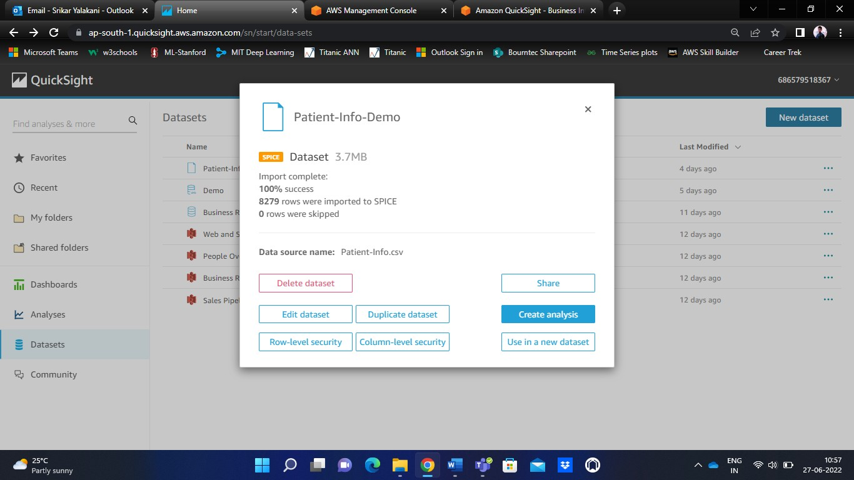

This image shows the dataset that is uploaded.

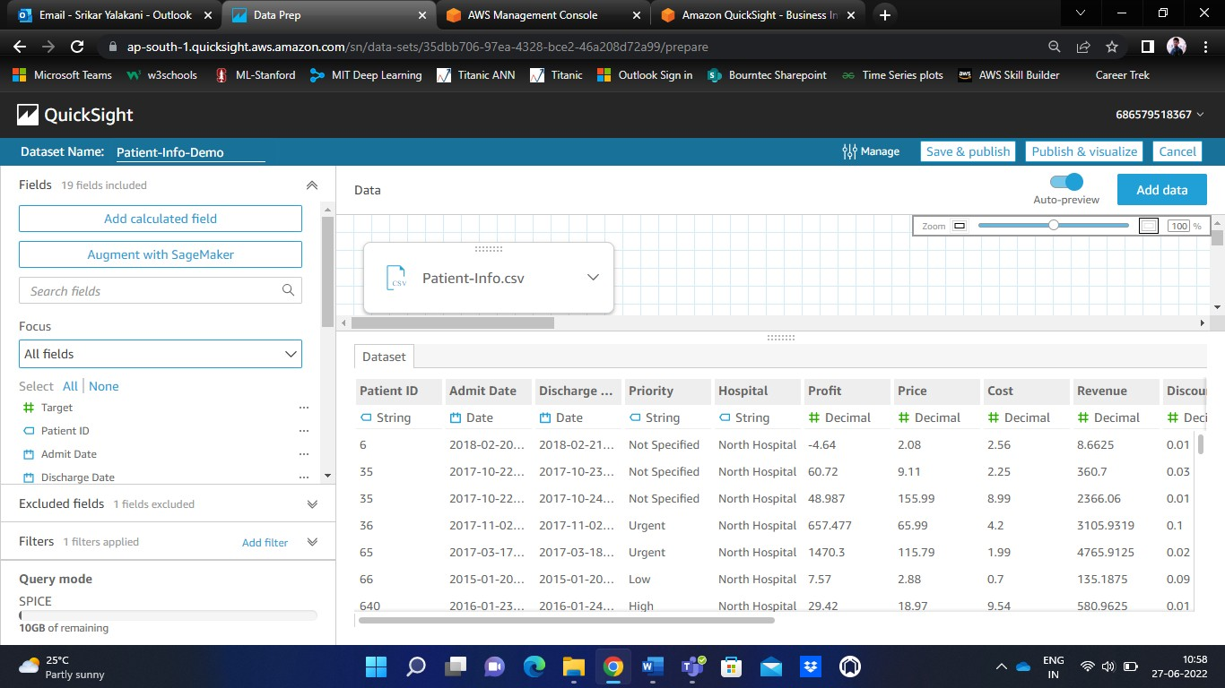

QuickSight also provides some advanced options like ‘Joins’ to perform datasets joining operations (Outer Join, Inner Join, Left and Right Joins).

To perform joining operation, click on ‘Add data’ on the top right-hand corner. Upload some dataset that you wish to join, and then click OK.

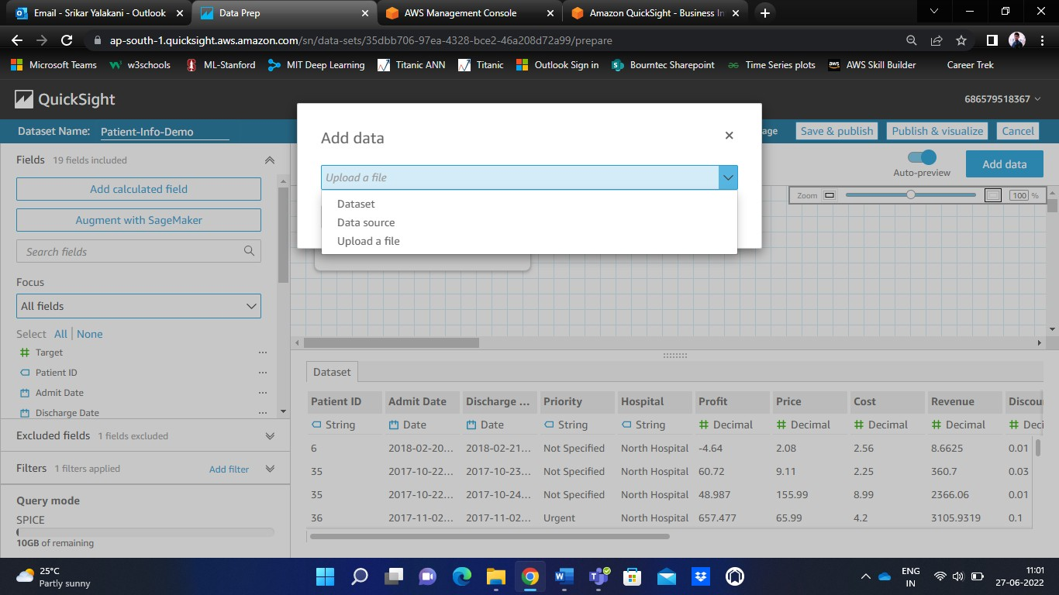

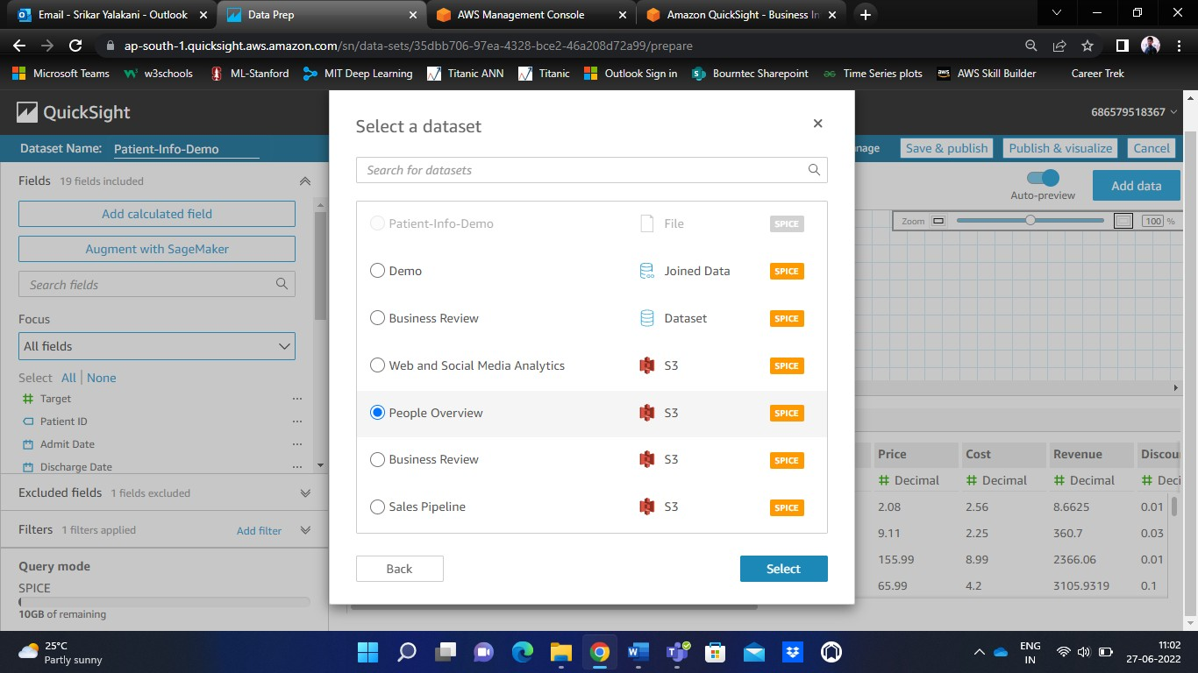

You will now notice the joining page, and various joining options.

I have selected a sample default dataset ‘People Overview’ to perform joining operation.

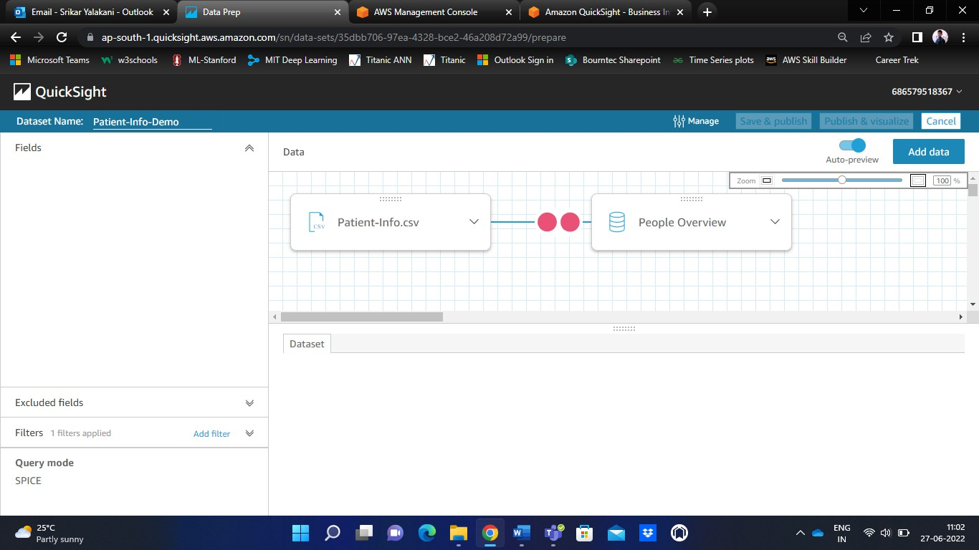

Click ‘Apply’ to join both the datasets.

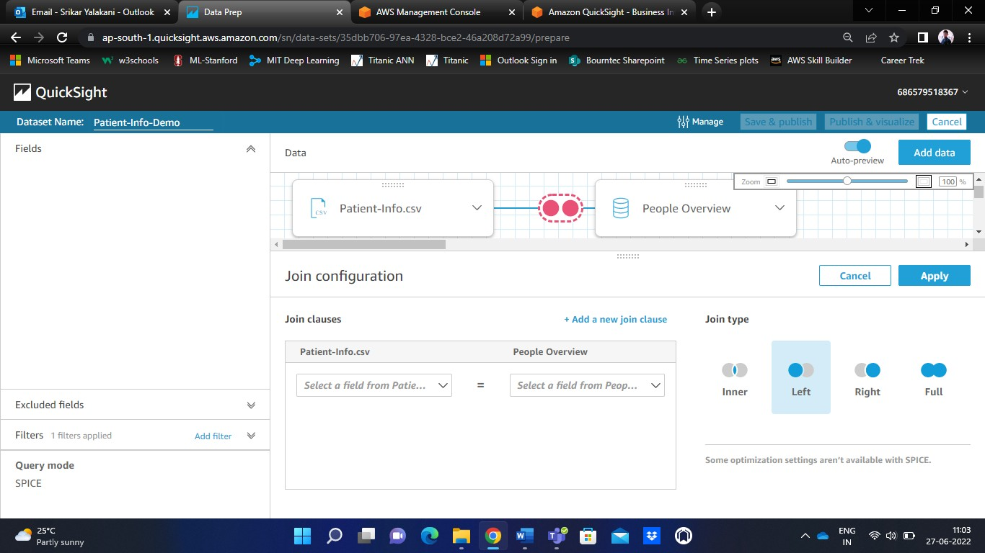

**Step – 4** Creating a Dashboard

To create a new dashboard, click on ‘Visualize’. It opens up an empty sheet with an empty AutoGraph.

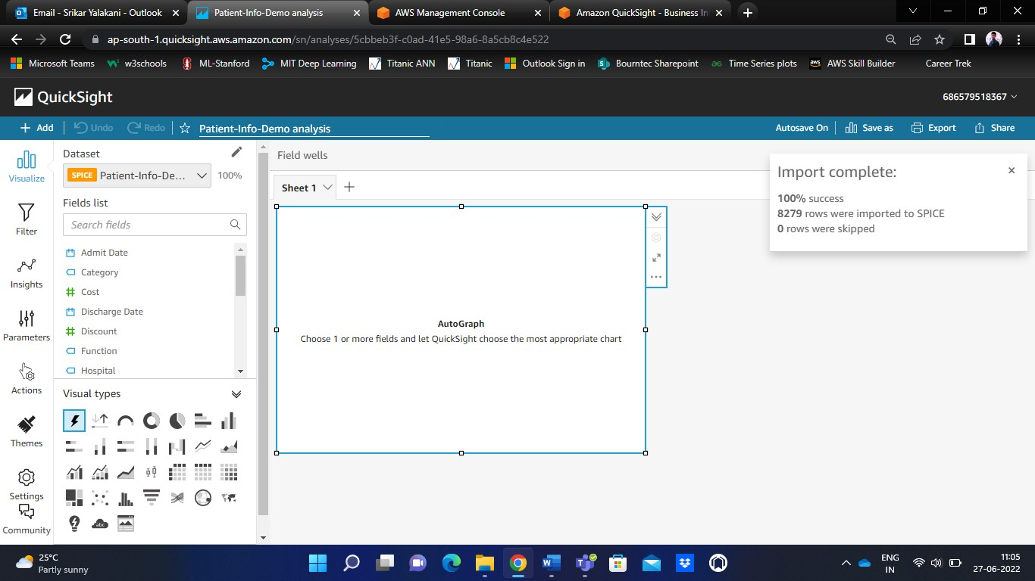

You can notice the different visual types like bar chart, histograms, pie chart, stacked horizontal and vertical bar charts, heatmap, pivot tables, etc.

To create a dashboard, we have to drag and drop those particular fields into the graphing space on the sheet and the visual is taken automatically. However, we can choose other visual if we wish to.

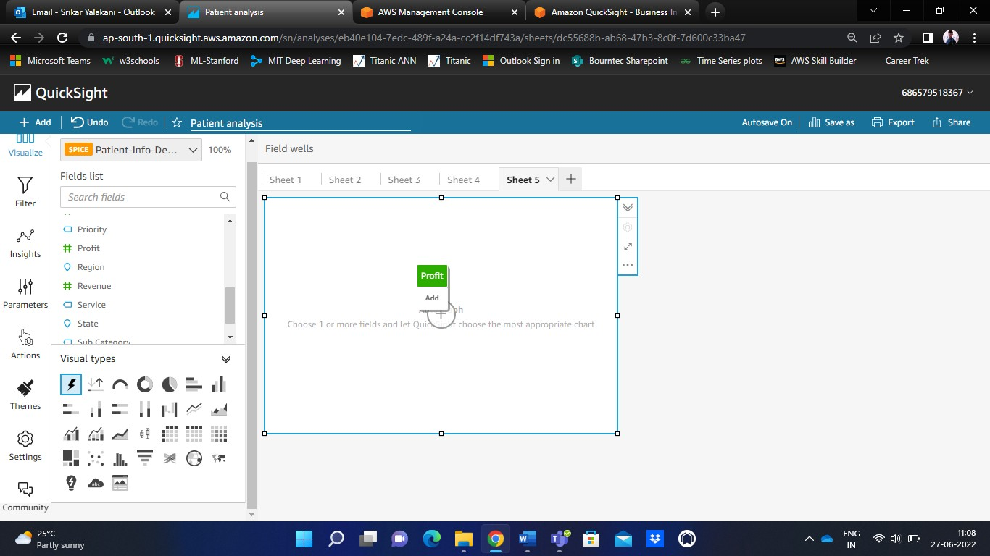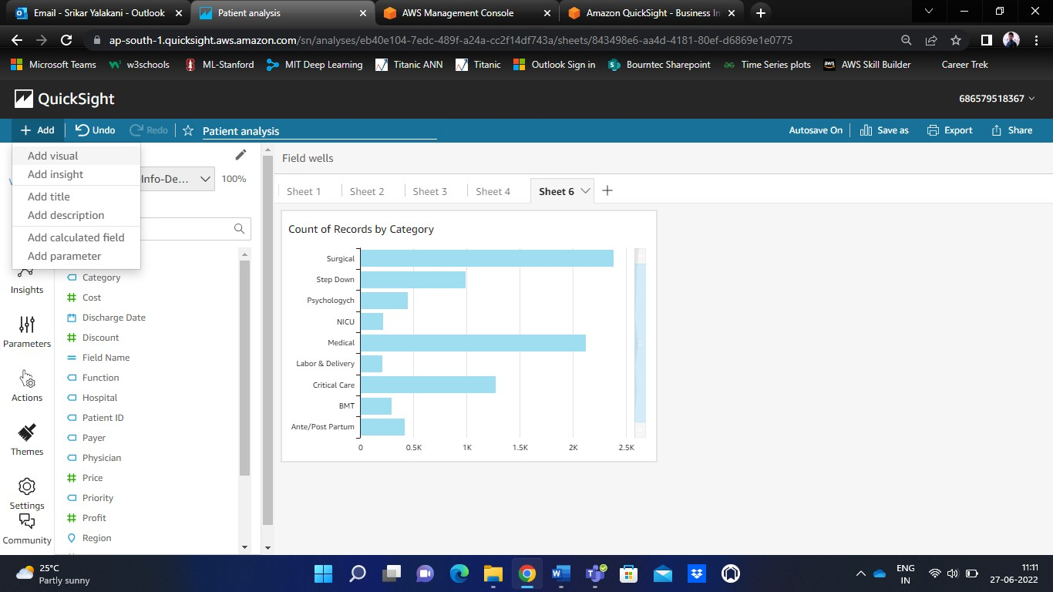

On the top left-hand corner, you can find ‘Add’ option. Under it you can find few options like – Add visual, Add insight, Add title, etc.

**Step – 5** Adding Filter to the Dashboard

Click on ‘Filter’ to add customizations to the dashboard. Under ‘Filter’, there will be many sub-options for customization. We can choose those according to our need.

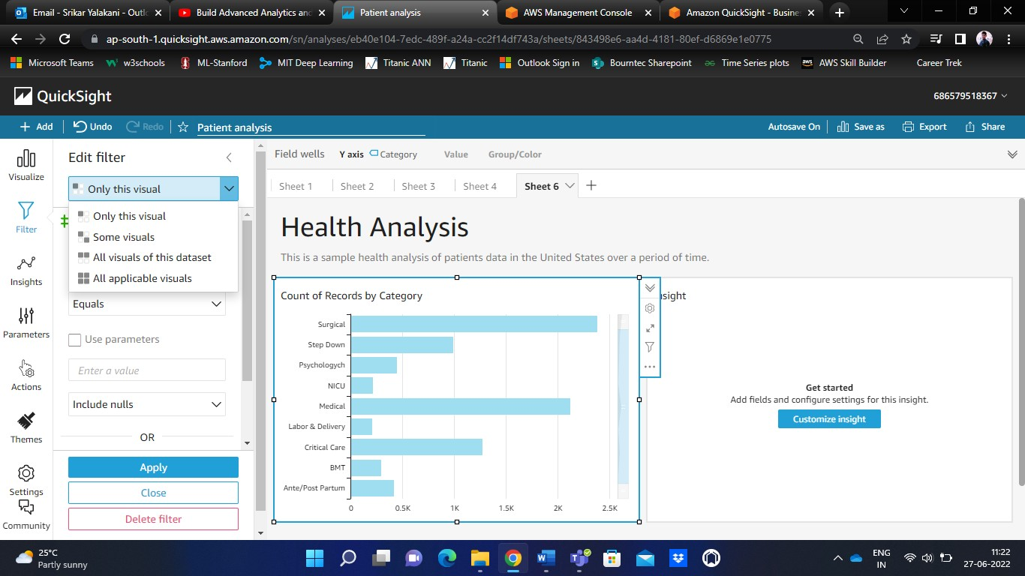

You can apply filter on one visual, or on a few visuals, or on all of the visuals depending upon the need.

There are certain filter options like – Aggregate functions (sum, average, mean, median, standard deviation, variance, etc., for better customization of the dashboards.

Finally, click on Apply to see the filtered dashboards.

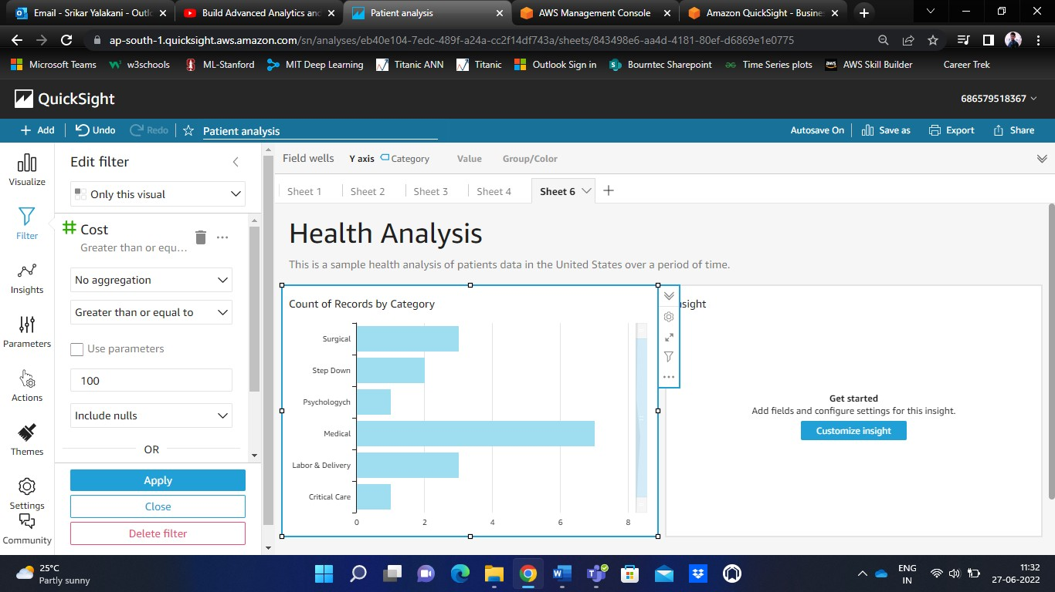

**Step – 6** Adding Parameters

‘Parameters’ are named variables that can transfer a value for use by an action or an object. By using parameters, you can create an easier way for a dashboard user to interact with dashboard features in a less technical way. Parameters can also connect one dashboard to another, allowing a dashboard user to drill down (probe) into data that's in a different analysis.

Click on ‘Parameters’. Name the parameter, and set the datatype.

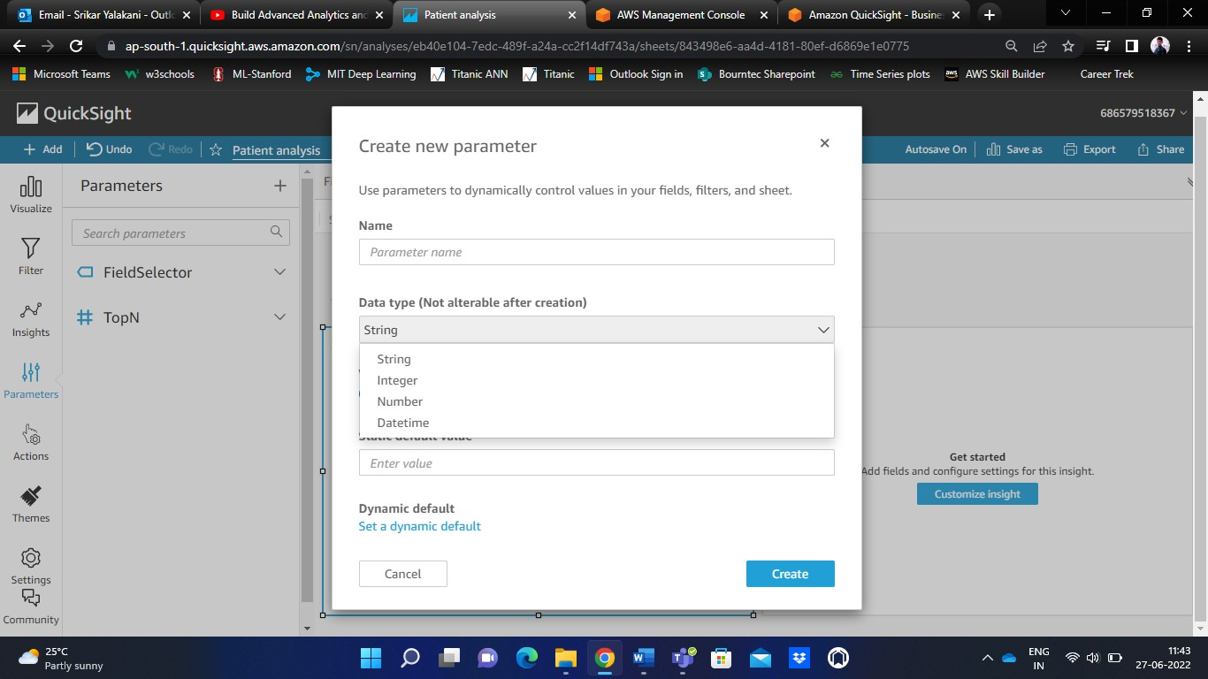

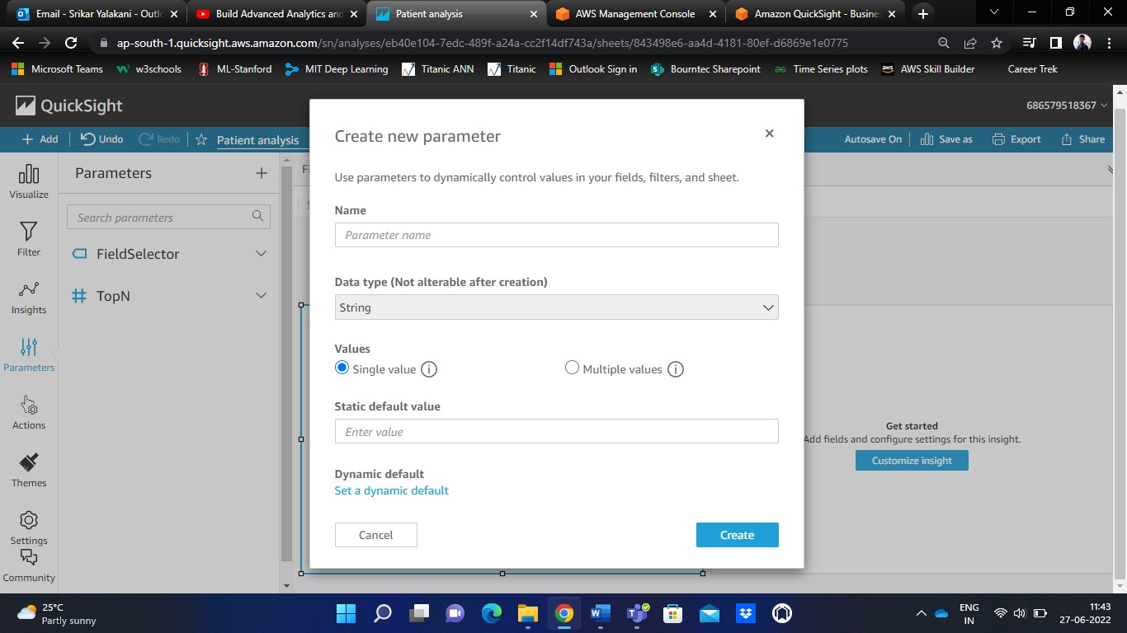

Mention the number of values to the taken i.e., either single value or multiple values.

Click on ‘Create’ for the parametric changes.

**Step – 7** Dealing with Insights and Anomaly Detection

You will find the ‘Insights’ option on the left-hand navigation pane of the QuickSight.

In Amazon QuickSight, you can add ready-to-use analytical computations to your analysis as widgets. There are two types of insights – Suggested insights and Customized insights.

Amazon QuickSight creates a list of suggested insights based on its interpretation of the data you put into your visuals. The list changes based on context. In other words, you can see different suggestions depending on what fields you add to your visual and what type of visual you choose. For example, if you have a time- series visualization, your insights might include period-over-period changes, anomalies, and forecasts. As you add more visualizations to your analysis, you generate more suggested insights.

Custom insights enable you to create your own computation, using your own words to give context to the fields that appear in the widget. When you create a custom insight, you add it to the analysis, and then choose what type of calculation that you want to use. Then, you can add text and formatting to make it look how you want. You can also add more fields, calculations, and parameters.

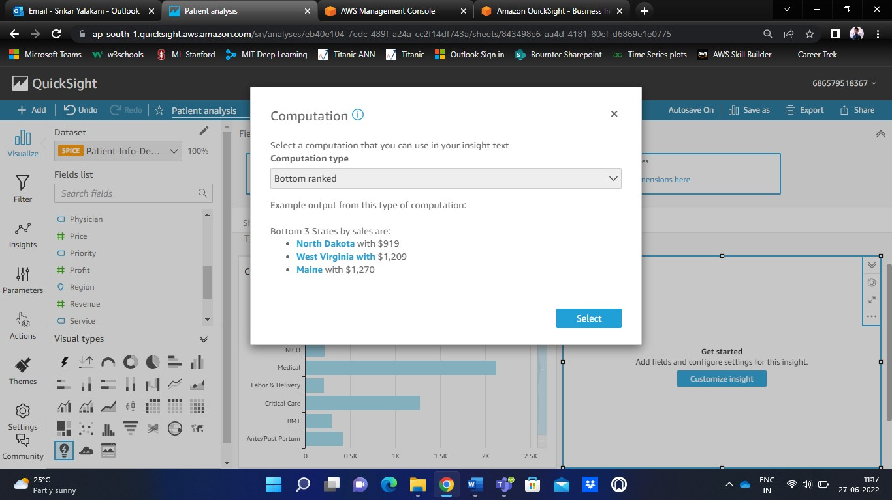

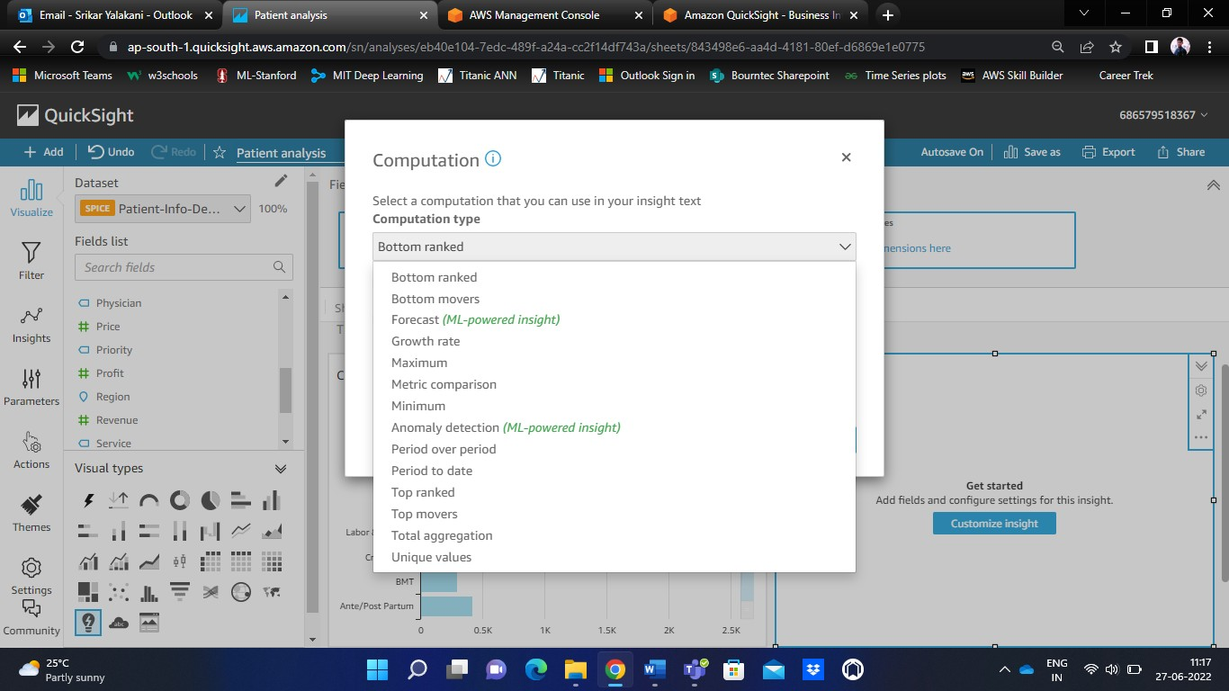

The ‘Insights’ by default shows some insights about the data that we are working on. An example of our Patient-data.csv insights are shown in the below image.

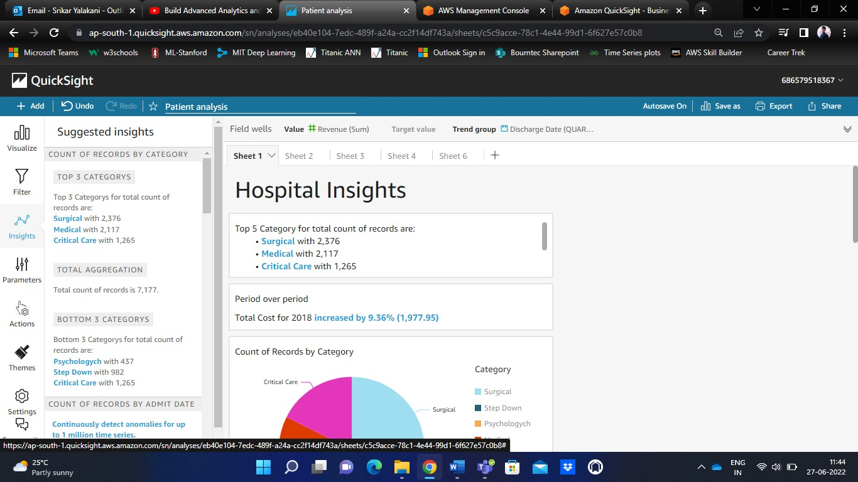

You can also customize your insights by defining the ‘Group by’ method as shown below.

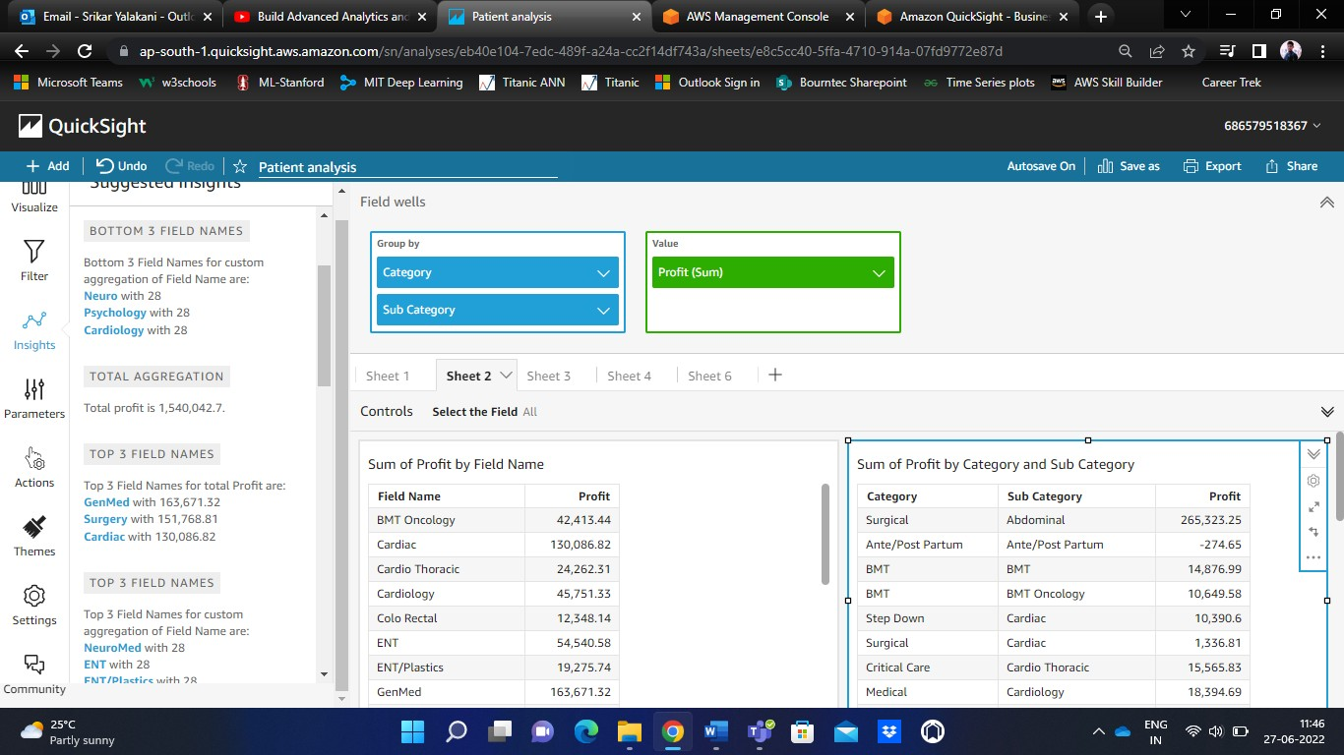

Under the ‘Computation’ in the insights, we can also perform ‘Anomaly Detection’.

The ML-powered anomaly detection computation searches your data for outliers. For example, you can detect the top three outliers for total sales on January 3, 2019. If you enable contribution analysis, you can also detect the key drivers for each outlier.

To use this function, you need at least one dimension in the *Time* field well, at least one measure in the *Values* field well, and at least one dimension in the *Categories* field well. The configuration screen provides an option to analyze the contribution of other fields as key drivers, even if those fields aren't in the field wells.

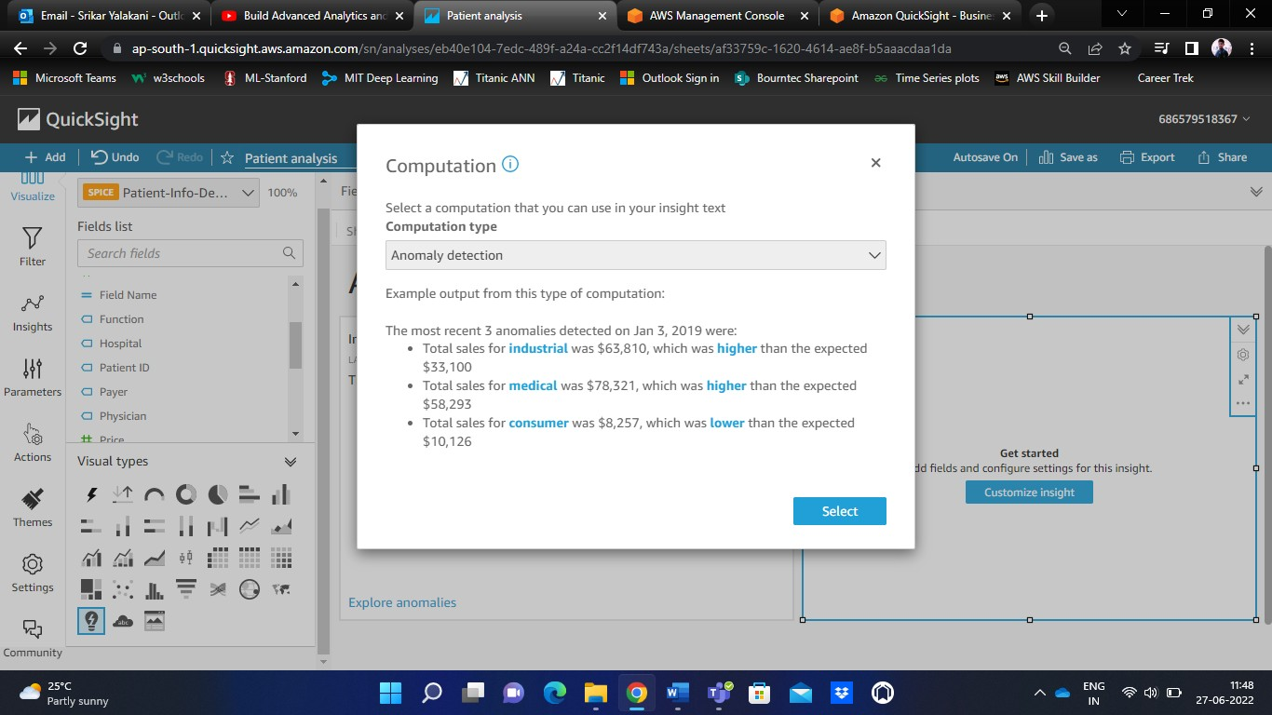

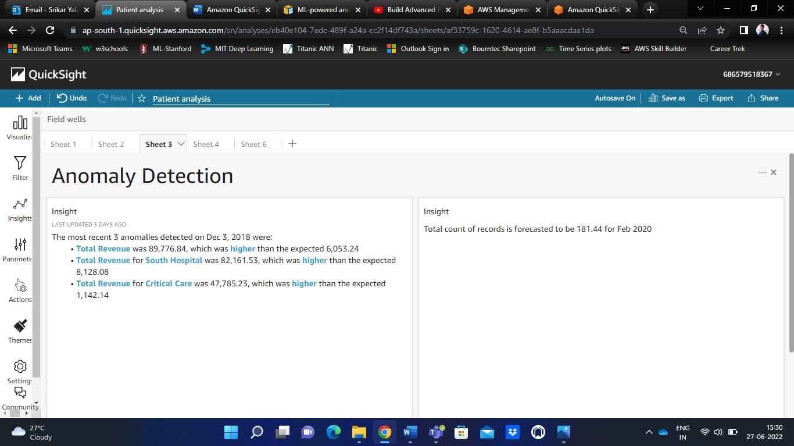

**Step – 8** Creating Pivot tables

A pivot table is an interactive way to quickly summarize large amounts of data. We can use pivot table to analyze numerical data in detail, and answer unanticipated questions about the data.

Under ‘Visuals’, click on ‘Pivot tables’ symbol to create a pivot table.

In the ‘Field walls’ dialogue box, drag and drop the relevant rows and columns along with the value respectively.

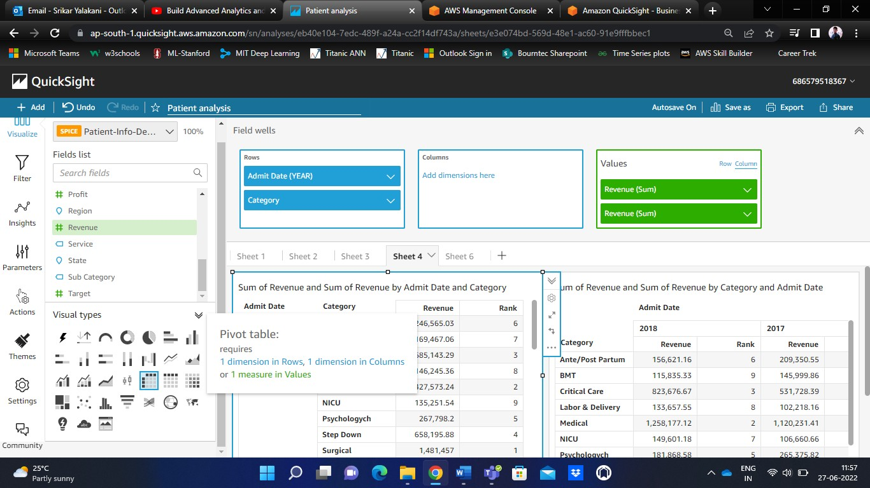

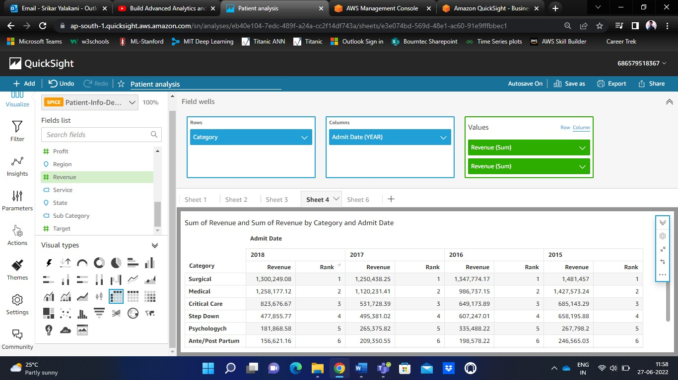

**Step – 9** Adding Calculated Fields to the data

A calculated field is a field that uses existing database fields and applies additional logic – it allows you to create new data from the already existing data. When you add a calculated field to a dataset during data preparation, it's available to all analyses that use that dataset. When you add a calculated field to a dataset in an analysis, it's available only in that analysis.

Click ‘Add’ on top left corner of the navigation pane and choose ‘Add calculated field’.



Name the calculated field and write its specific condition.

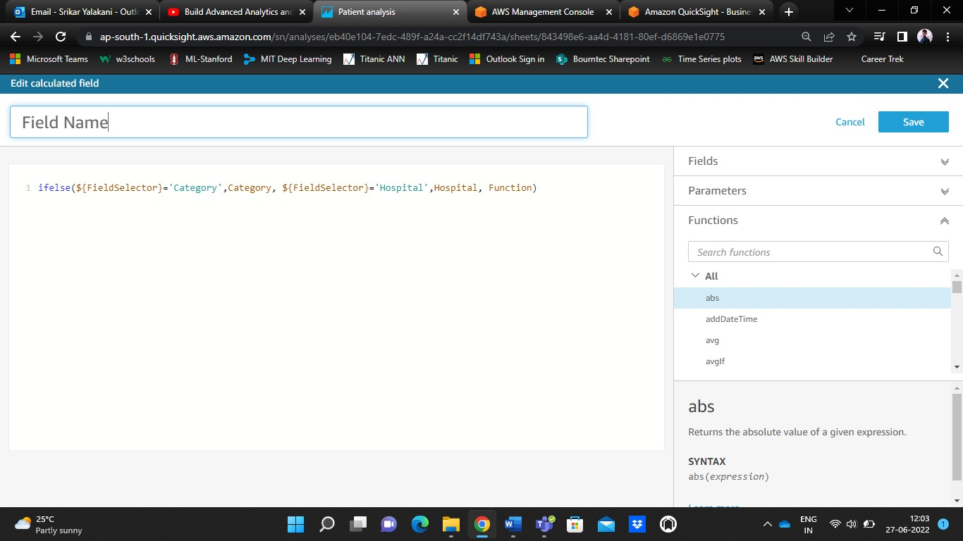

I have created a sample calculated field named ‘Field Name’. You can notice the same in the Fields list shown below.

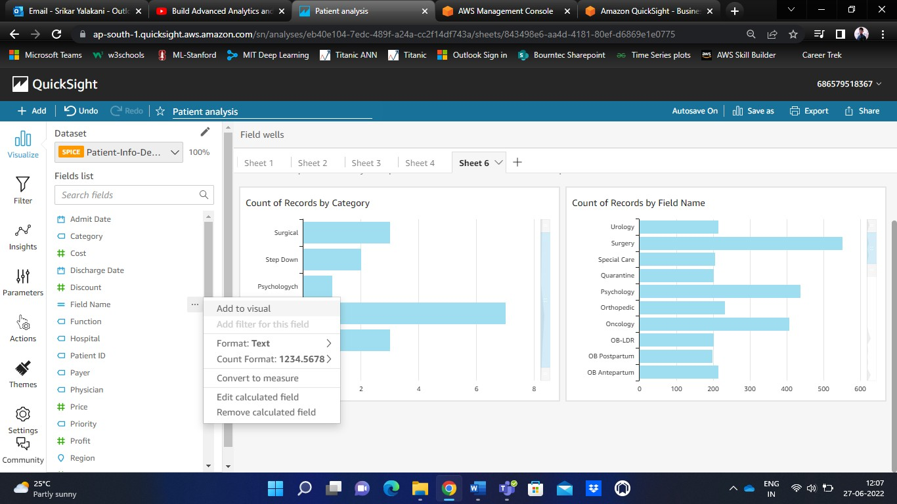

**Step – 10** Publishing and Sharing the dashboards

On the top right-hand corner of the navigation pane, there is ‘Share’ option. It has two options in it – Publish dashboard and Share analysis.

To publish the dashboard, select the appropriate visual. Then click on ‘Publish dashboard’ to publish the current dashboard by naming it.

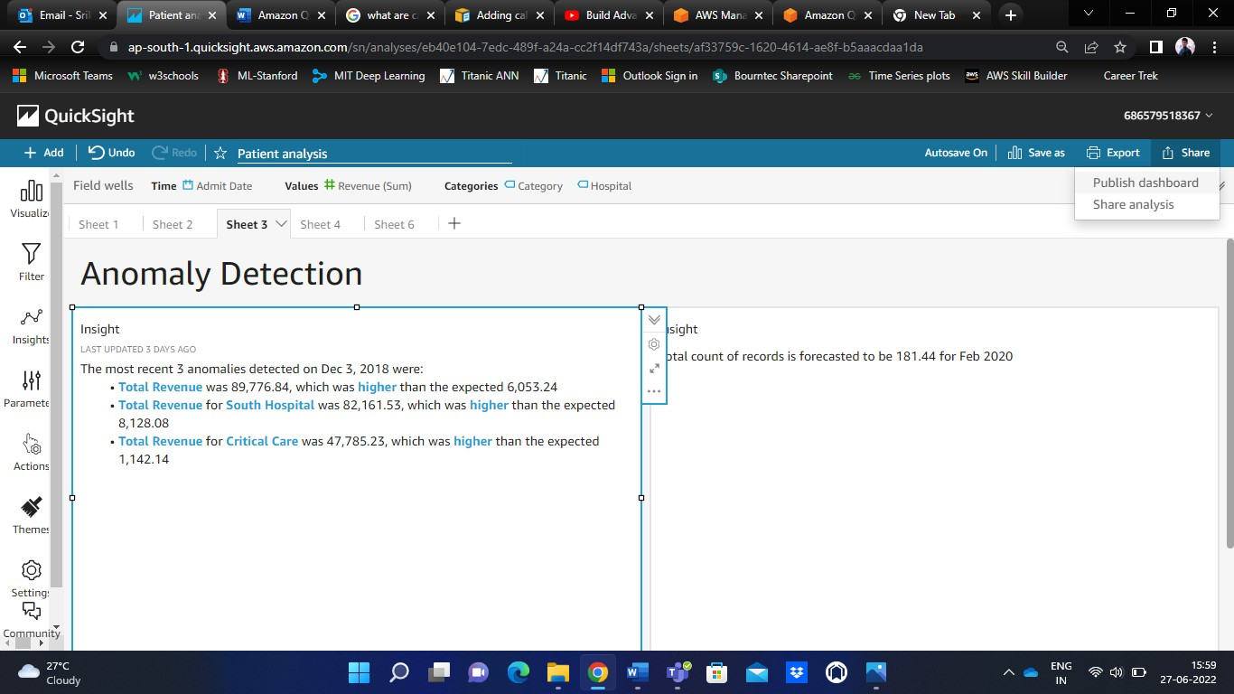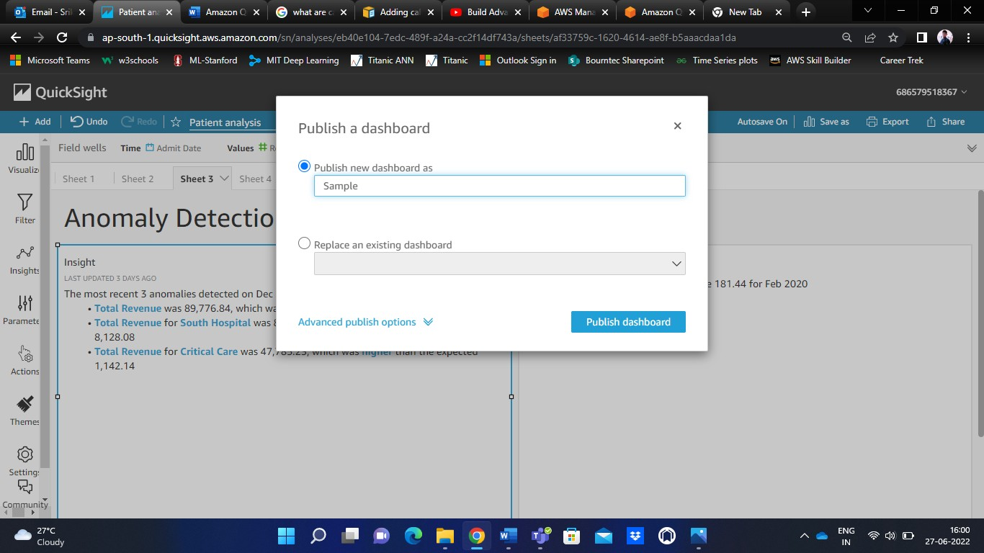

To share the dashboard, click on ‘Share dashboard’. Mention the email address correctly and then click on share.

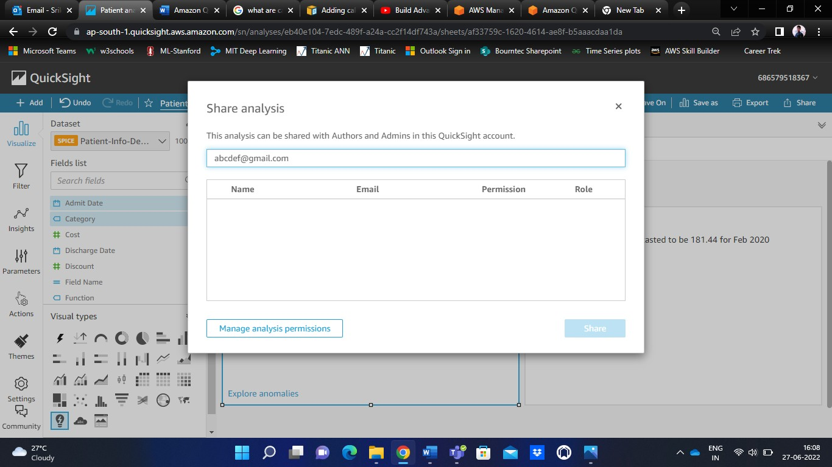

Check your concerned email id to view the shared dashboard.

While sharing the dashboard, we can give the access type to the concerned user (read access, modify) depending upon our requirement.

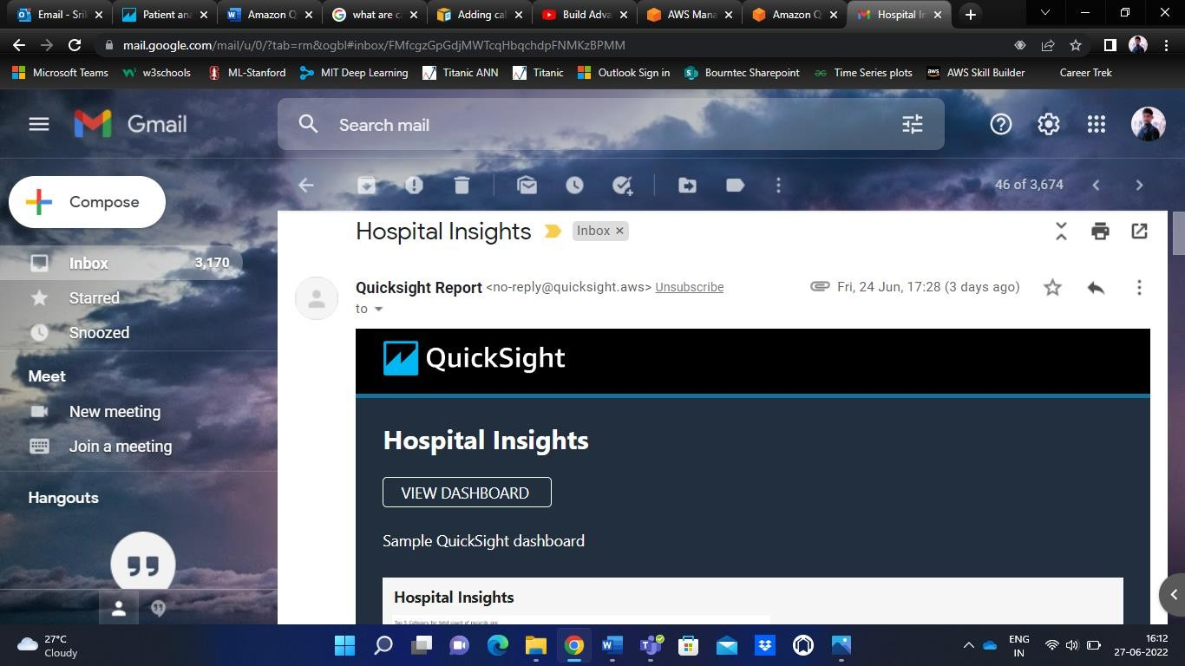

Under the ‘Export’ option, there are Print and Download as PDF options. We can either print it or download it.

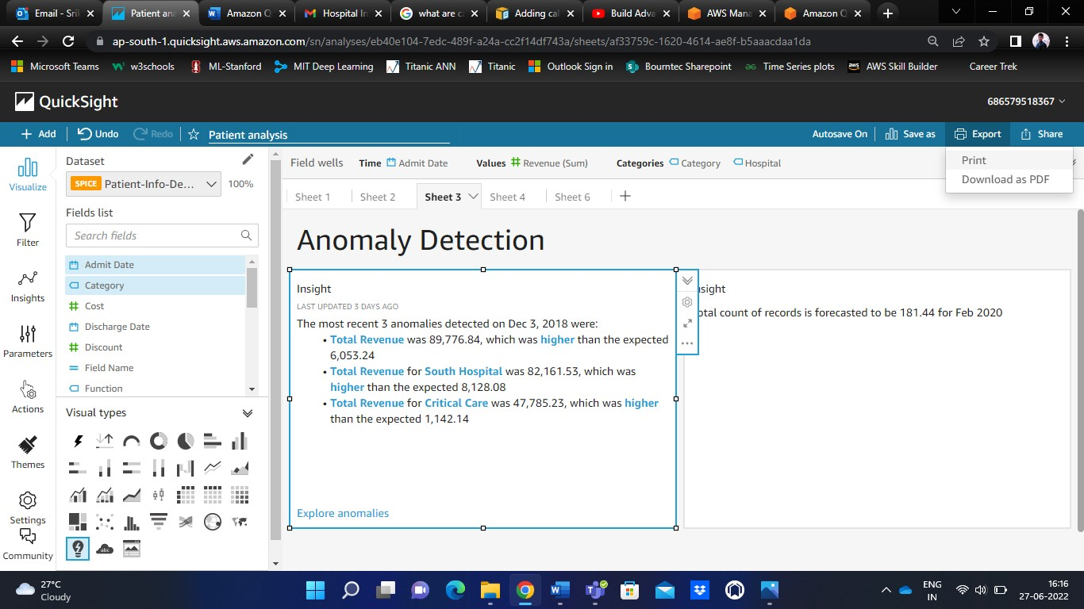

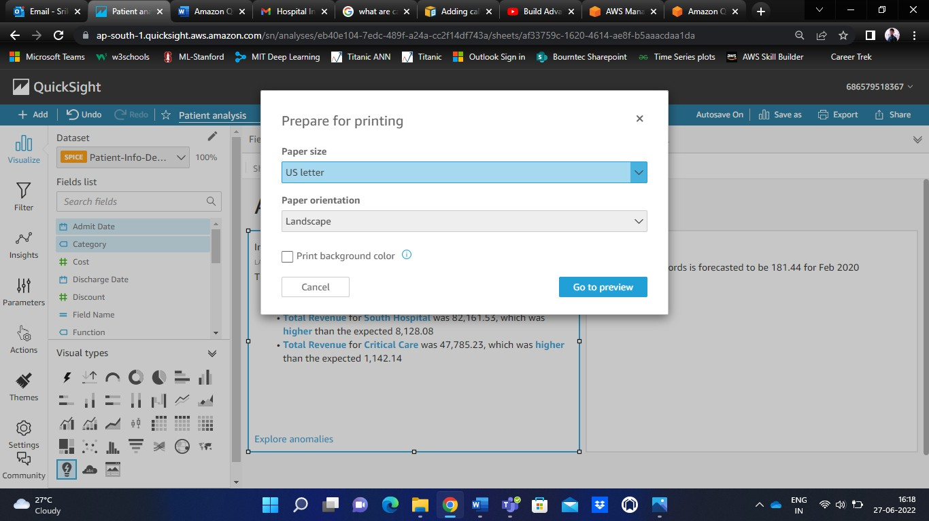

A view of the final sample dashboard

